[GitHub实战系列~2.把本地项目提交到github中 2015-12-10](http://www.cnblogs.com/dunitian/p/5035625.html)

**GitHub实战系列汇总：**<http://www.cnblogs.com/dunitian/p/5038719.html>

**——————————————————————————————————————————————————————**

**很多人问，明明有git gui 和 github可以直接图形化操作的吗？全部指令干啥？？？**

**呃(⊙o⊙)…呃(⊙o⊙)… ===> 装逼~**

**O(∩_∩)O~，开玩笑的，其实就是为了通用和熟悉git，linux里面照样这样用，多熟悉点基础指令很有用的，**

**如果觉得顿时不开心了、无爱了==>推荐你快速入门：**http://www.imooc.com/learn/390

**———————————————————————————————————————————————————————**

**实例1：**

1.上面步骤和昨天一样，先在github里面新建一个项目，然后clone一份到本地（**我这边就不重新截图了，引用一下昨天的步骤**）

**10.在github里面创建一个公开仓库（私有的收费）并初始化仓库（最下面的复选框，最下面的两个下拉列表后面说）**



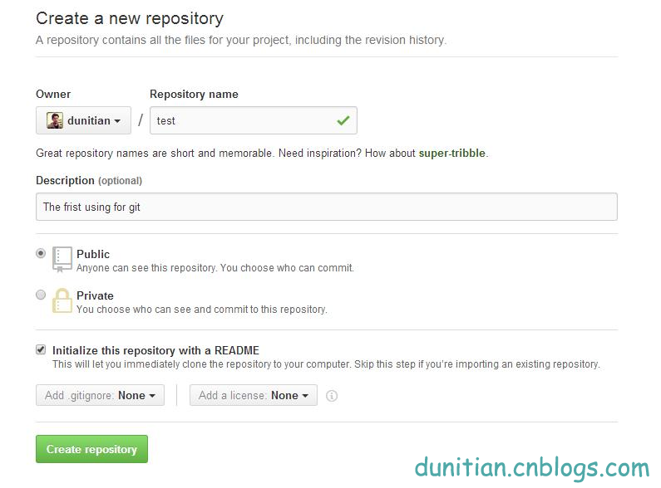  
————————————————————————————————————————  
**11.复制一份github ssh库的地址，一会儿有用**

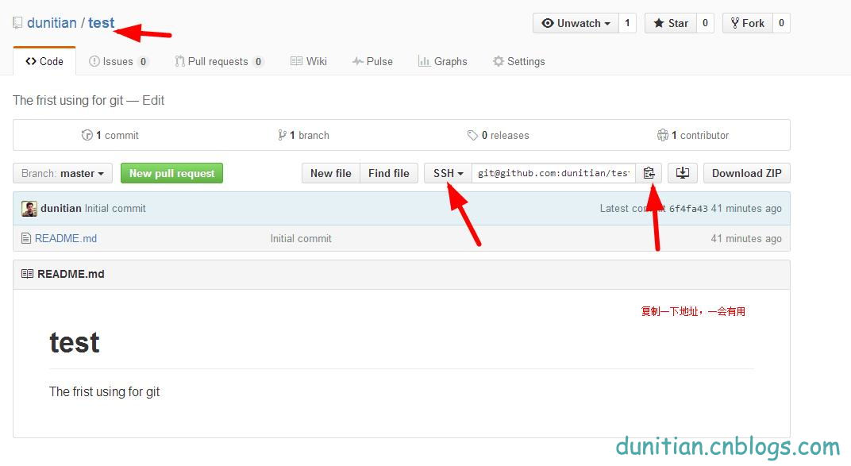  
————————————————————————————————————————  
**12.克隆一份到本地**

**git clone git@github.com:dunitian/test.git（刚才的地址）**

————————————————————————————————————————  
Cloning into 'test'...  
Warning: Permanently added the RSA host key for IP address '192.30.252.131' to the list of known hosts.  
remote: Counting objects: 3, done.  
remote: Total 3 (delta 0), reused 0 (delta 0), pack-reused 0  
Receiving objects: 100% (3/3), done.  
Checking connectivity... done.  
————————————————————————————————————————

=======================开始~==========================================

2.把本地文件拖到git项目文件夹里面（后面讲怎么过滤文件）

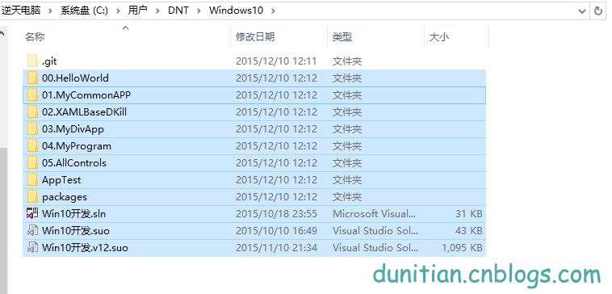

3.打开git bash 进入项目文件夹，添加全部（*） 提交

|  |  |
| --- | --- |
| 1  2  3  4  5  6  7  8  9  10  11  12  13  14  15  16 | DNT@DESKTOP-PTACRF6 MINGW64 ~  $ cd Windows10/    DNT@DESKTOP-PTACRF6 MINGW64 ~/Windows10 (master)  $ ls    DNT@DESKTOP-PTACRF6 MINGW64 ~/Windows10 (master)  $ ls  00.HelloWorld/   02.XAMLBaseDKill/  04.MyProgram/    AppTest/   Win10开发.sln  Win10开发.v12.suo  01.MyCommonAPP/  03.MyDivApp/       05.AllControls/  packages/  Win10开发.suo    DNT@DESKTOP-PTACRF6 MINGW64 ~/Windows10 (master)  $ git add *    DNT@DESKTOP-PTACRF6 MINGW64 ~/Windows10 (master)  $ git commit -m "逆天WP-Win10开发笔记源码（学习ing）" |

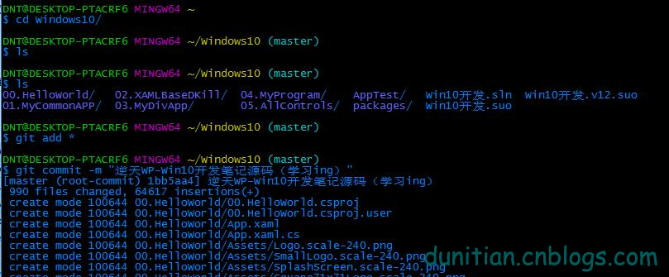

4.push到github里面

|  |  |
| --- | --- |
| 1  2 | DNT@DESKTOP-PTACRF6 MINGW64 ~/Windows10 (master)  $ git push |

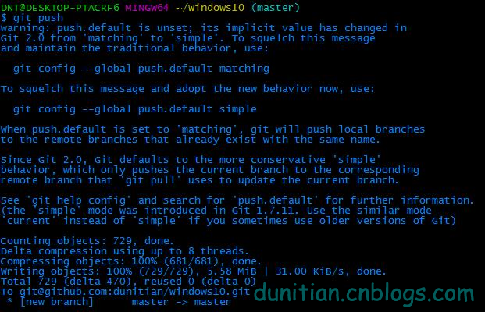

———————————————————————记录1———————————————————————————————————

|  |  |
| --- | --- |
| 1  2  3  4  5  6  7  8  9  10  11  12  13  14  15  16  17  18  19  20  21  22  23  24  25  26  27  28  29  30  31  32  33  34  35  36  37  38  39  40  41  42  43  44  45  46  47  48  49  50  51  52  53  54  55  56  57  58  59  60  61 | DNT@DESKTOP-PTACRF6 MINGW64 ~  $ git clone git@github.com:dunitian/Windows10.git  Cloning into 'Windows10'...  Warning: Permanently added the RSA host key for IP address '192.30.252.129' to the list of known hosts.  warning: You appear to have cloned an empty repository.  Checking connectivity... done.    DNT@DESKTOP-PTACRF6 MINGW64 ~  $ cd Windows10/    DNT@DESKTOP-PTACRF6 MINGW64 ~/Windows10 (master)  $ ls    DNT@DESKTOP-PTACRF6 MINGW64 ~/Windows10 (master)  $ ls  00.HelloWorld/   02.XAMLBaseDKill/  04.MyProgram/    AppTest/   Win10开发.sln  Win10开发.v12.suo  01.MyCommonAPP/  03.MyDivApp/       05.AllControls/  packages/  Win10开发.suo    DNT@DESKTOP-PTACRF6 MINGW64 ~/Windows10 (master)  $ git add *    DNT@DESKTOP-PTACRF6 MINGW64 ~/Windows10 (master)  $ git commit -m "逆天WP-Win10开发笔记源码（学习ing）"  [master (root-commit) 1bb5aa4] 逆天WP-Win10开发笔记源码（学习ing）   990 files changed, 64617 insertions(+)   create mode 100644 00.HelloWorld/00.HelloWorld.csproj   create mode 100644 00.HelloWorld/00.HelloWorld.csproj.user   create mode 100644 00.HelloWorld/App.xaml     create mode 100644 packages/repositories.config    DNT@DESKTOP-PTACRF6 MINGW64 ~/Windows10 (master)  $ git push  warning: push.default is unset; its implicit value has changed in  Git 2.0 from 'matching' to 'simple'. To squelch this message  and maintain the traditional behavior, use:      git config --global push.default matching    To squelch this message and adopt the new behavior now, use:      git config --global push.default simple    When push.default is set to 'matching', git will push local branches  to the remote branches that already exist with the same name.    Since Git 2.0, Git defaults to the more conservative 'simple'  behavior, which only pushes the current branch to the corresponding  remote branch that 'git pull' uses to update the current branch.    See 'git help config' and search for 'push.default' for further information.  (the 'simple' mode was introduced in Git 1.7.11. Use the similar mode  'current' instead of 'simple' if you sometimes use older versions of Git)    Counting objects: 729, done.  Delta compression using up to 8 threads.  Compressing objects: 100% (681/681), done.  Writing objects: 100% (729/729), 5.58 MiB | 31.00 KiB/s, done.  Total 729 (delta 470), reused 0 (delta 0)  To git@github.com:dunitian/Windows10.git   * [new branch]      master -> master |

———————————————————————记录2———————————————————————————————————  
DNT_PC@DNT_PC-PC MINGW32 /d/gitworks/test (master)  
$ git commit -m "直接添加本地文件库到github"  
[master f33514f] 直接添加本地文件库到github  
2 files changed, 223 insertions(+)  
create mode 100644 "\345\221\275\344\273\244.txt"  
create mode 100644 "\350\256\260\345\275\225.txt"

DNT_PC@DNT_PC-PC MINGW32 /d/gitworks/test (master)  
$ git push  
warning: push.default is unset; its implicit value has changed in  
Git 2.0 from 'matching' to 'simple'. To squelch this message  
and maintain the traditional behavior, use:

git config --global push.default matching

To squelch this message and adopt the new behavior now, use:

git config --global push.default simple

When push.default is set to 'matching', git will push local branches  
to the remote branches that already exist with the same name.

Since Git 2.0, Git defaults to the more conservative 'simple'  
behavior, which only pushes the current branch to the corresponding  
remote branch that 'git pull' uses to update the current branch.

See 'git help config' and search for 'push.default' for further information.  
(the 'simple' mode was introduced in Git 1.7.11. Use the similar mode  
'current' instead of 'simple' if you sometimes use older versions of Git)

Counting objects: 4, done.  
Compressing objects: 100% (4/4), done.  
Writing objects: 100% (4/4), 3.91 KiB | 0 bytes/s, done.  
Total 4 (delta 0), reused 0 (delta 0)  
To git@github.com:dunitian/test.git  
4e69105..f33514f master -> master  
————————————————————————————————————————